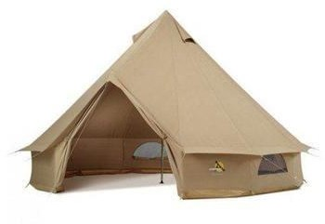
F
A

B

C
G D

E

- TOP OF TENT TO TOP OF DOORWAY 6.5 ft

- POLE HEIGHT 8 ft

- DOORWAY HEIGHT 5 ft

- WALL HEIGHT 3 ft

- DIAMETER 13 ft

- AIR VENTS 4 with mosquito netting

- ZIP WINDOWS 4 with mosquito netting (Note groundsheet not shown on picture above)

Details

Tent Sides can unzip from groundsheet and tie up – cotton ties Waterproof

Groundsheet PVC 540g per sqm
Zips into tent
3.5 “ high but lays flat when unzipped (keeps water out)
Doorway has extra zips to allow doorway section to lay flat when rest of groundsheet is zipped in
Rivetted holes for pegs

Poles Galvanised steel Central pole
A-Frame pole for doorway with spike at top of A-frame (with rubber washer round to protect canvas plus riveted hole in canvas)

Pegs 24 (groundsheet and guy ropes)
Strong steel – must not bend when hammered

Guy ropes 11 & 1 extra long for door

Carry bag All contents in a zip carry bag with handle
Bag must be large enough to make packing away easy

Total weight 48.5 lbs

